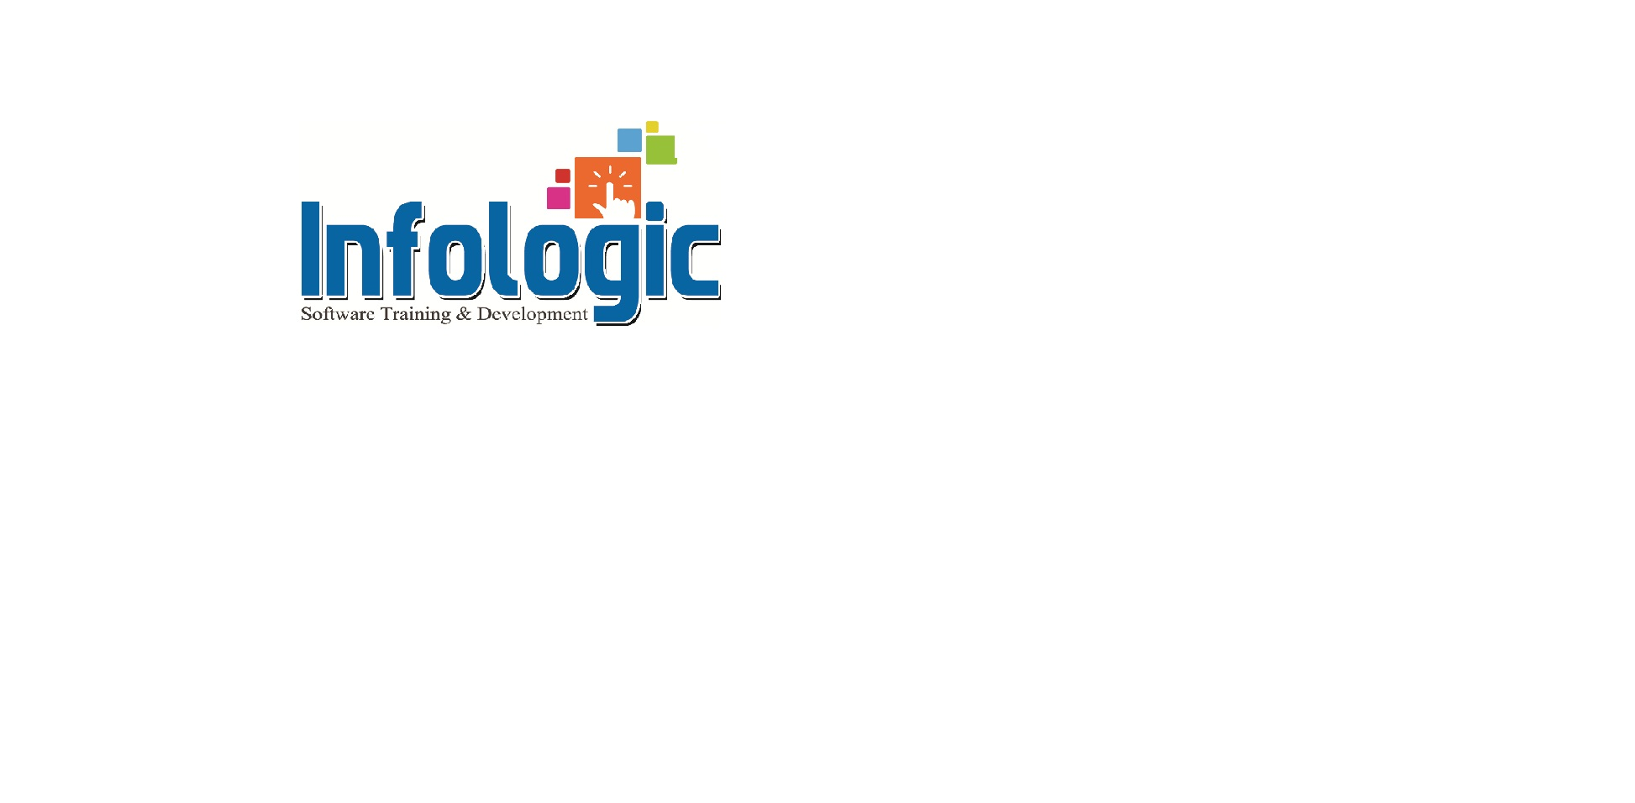

**Address: Flat 102, AnnapurnaBlock, AdityaEncalve, Ameerpet, Hyd Ph: 9014375678**

ASP.NET

INTRO TO WEB TECHNOLOGIES

* HTML
* Client side scripting langs
* IIS Architecture
* Server side programming with ASP

ASP.NET INTRO

* What is ASP.NET
* ASP vs ASP.NET
* Inline Technique and code behind

SERVER SIDE CONTROLS

* Client side control vs Server side controls
* Examples on Web server controls
* ASP.NET page Execution Architecture
* STATE MANAGEMENT

Cookies

* Session state
* Session Tracking Arch
* Application object
* Session and App events
* Global AJAX
* Content
* View stat

ADO.NET

* Introduction to ADO.NET providers
* Data Reader
* Dataset
* Datalist
* Reapeter
* Datasource controls
* Gride view
* Details view
* List view

LINQ

* Intro to Linq
* Linq to object
* Linq to XML
* Linq to SQL

CACHING

* Importance of Caching ASP3.0 supporting for caching
* Types of caching in ASP.NET
* Output Caching
* Web user control(VS)custom control
* Fragment caching
* Data caching vs Application object

ASP.NET CONFIGURATION

* Machine config vs Web config
* App setting
* Compilation setting
* Custom error setting
* Session state setting
* Enhancement in ASP.NET
* Inprocess vs Out process session stat
* State server and SQL server
* Cookie less session

ASP.NET TRACING

* Page level
* Application level

SECURITY IN ASP.NET

* Authentication & Authorization
* Windows Based Authentication
* Form Based Authentication
* Passport Authentication
* Membership

WEB SERVICES

E-MAIL SERVER

THEME AND SKIN

MASTER PAGES

C#.NET

.NET ENTERPRISE ARCHITECTURE

* Introduction to the .Net platform
* Common language Run Time (CLR)
* The Common type Specification (CTS)
* The Common Language Specification(CLS)
* Microsoft Intermediate Language(MSIL)

C#.NET Language Basics

* Data types
* Type conversion
* Boxing & Unboxing
* Conditional Statements
* Looping
* Methods in c#
* Properties
* Arrays
* Indexors
* Structures,Enumerations
* Strings
* Collections

Objects Oriented Programming

* Oops concepts
* Encapsulation
* Inheritance
* Polymorphism
* Class and object
* Constructors
* Dynamic types
* Optional parameters
* Names & optional arguments
* Covariant generic type parameters
* Destructors
* Method overloading
* Method overriding
* Early binding,Late binding
* Abstract Classes
* Interfaces
* Multiple Inheritence
* Generic classes
* Static classes
* Static constructors
* Object initialize

Exception Handling

* System Defined Exception
* Custom Exceptions
* Try, Catch, Finally
* Throwing exceptions

GUI Application Development

* Windows forms and controls
* Creating menus
* Toolbars,Image list
* Tree view,List view
* Notify Icon
* Error provider

Data Base Programming(ADO.NET)

* ADO.NET introduction
* Data providers in .net
* Introduction to managed and unmanaged
* Providers
* Data Readers
* Dataset and Data Adapters
* Datagrid View with DML operations sorting and paging etc
* SQL Datasource ,XML Datasource etc
* Creating Relations and Transcations
* Linq programming

ASSEMBLIES

* Private Assembles
* Shared assembles
* Single file Assembles
* Multifile Assembles
* Global Assembly Cache(GAC)

Delegates

* Function Pointers
* Multi cast delogtes

User Controls and event handling

* User defined control
* Inherited control
* Inherited forms
* Event handling

Pointers

* Value types,Reference types
* Unsafe structures and pointers

Distributed Technologies and .NET Remoting

* Distributed architecture
* DCOM,RMI,CORBA
* Channels (TCP HTTP)
* Marshal by value
* Marshal by reference
* Server Activated
* Client Avctivated
* Remoting Architecture

File handling

* System IO namespace
* File stream
* Stream Reader
* Stream Writer
* Fileinfo
* Directory info

Windows Service

* Service base class
* Service process installer
* Service installer
* Creating a Windows Service
* Installutill.exe

WCF programming

* Shapes
* Transformation
* Animation

Multi threading

* System threading
* Thread synchronization
* Critical sections
* Thread life cycle

Security in .NET

* Cryptography
* Role based security

Note: After the course, I will develop a project like CMS Application or shopping cart or Social Networking site or any portal with real time scenarios.